标题：Stars in Their Constellations: Great Person or Great Team?
作者及机构:
Denisa Mindruta: Strategy and Business Policy, HEC Paris, 78350 Jouy-en-Josas, France
Janet Bercovitz: Leeds School of Business, University of Colorado Boulder, Boulder, Colorado 80309
Vlad Mares: INSEAD Europe Campus, Boulevard de Constance, F-77305 Fontainebleau Cedex, France
Maryann Feldman: ASU School of Public Affairs, Phoenix, Arizona 85004
摘要: Although much attention is accorded to star performers, this paper considers the extent to which stars, themselves, benefit from the contribution of their collaborators (the constellation). By considering stars, constellations, and the synergies between them, we address a key question: To what extent is collaboration performance driven by the great individual or by great constellations? We introduce a novel approach that uses a matching model to uncover the complementarities driving collaboration formation. We use formal value-capture theory to estimate the relative contribution of stars and constellations to joint value creation. Analyzing a sample of academic research collaborations, we document that stars’ relative contribution exceeds that of their constellations in less than 15% of collaborations, although constellations provide a greater relative contribution in 9%. In most collaborations, neither party dominates: Innovation is a collective endeavor driven equally by the star and the constellation. Joint value creation and relative contribution are explained by the subtle interplay between complementarities in joint work and the substitutability of collaborative parties in the market. Joint value creation increases with the strength of complementarities between parties in a match. Relative value creation, and hence dominance, increases with the substitutability of one’s collaborative partner. Interestingly, joint value creation is greatest in collaborations where both stars and constellations offer bundles of rare attributes and where neither the star nor the constellation dominates.
AI标题: 明星科学家光环褪色：互补性协同驱动团队创新跃升
AI精炼: 这篇管理学领域的论文研究了科研合作中明星科学家与团队（"星座"）对创新成果的相对贡献问题。针对现有文献过度关注明星个体贡献、忽视团队协同效应的问题，作者提出了一个融合匹配模型与价值捕获理论的双阶段方法：首先通过结构模型分析合作形成的互补性机制，继而构建反事实匹配场景计算贡献区间。基于555项高校发明披露数据的实证研究表明，仅14.3%的合作由明星主导，9.5%由团队主导，76%的合作呈现双向溢出效应——当双方都具有市场稀缺属性时，协同价值最大但无人占据主导。该方法突破了传统工具变量法和固定效应模型的局限，首次将合作选择内生性、多维互补性和市场替代性纳入统一分析框架，为评估非随机匹配场景下的价值分配提供了新工具。
关键词:
匹配模型
价值捕获理论
反事实匹配场景
多维互补性
结构模型
替代性分析
贡献区间估计
协同效应
学术要点: 学术要点 1：价值捕获区间（Value-Capture Interval） 通过匹配模型计算合作双方贡献的上下限区间，反映在反事实场景中合作方被替代时的价值变动范围。|||
学术要点 2：属性束稀缺性（Bundle Rarity） 合作双方在匹配市场中提供不可替代的多维属性组合（如知识结构、研究质量等），决定联合价值创造潜力。|||
学术要点 3：非支配型合作（Nondominating Collaboration） 77%的合作中明星科学家与团队均无绝对贡献优势，体现双向知识溢出效应与协同创新本质。|||
学术要点 4：替代性驱动支配（Substitutability-Driven Dominance） 当合作方在匹配市场存在近似替代者时，主导方可通过更优谈判地位获取更高价值捕获比例。|||
学术要点 5：反事实再匹配（Counterfactual Rematching） 基于稳定匹配假设构建替代性合作组合，用于量化移除特定合作方后的价值损失边界。
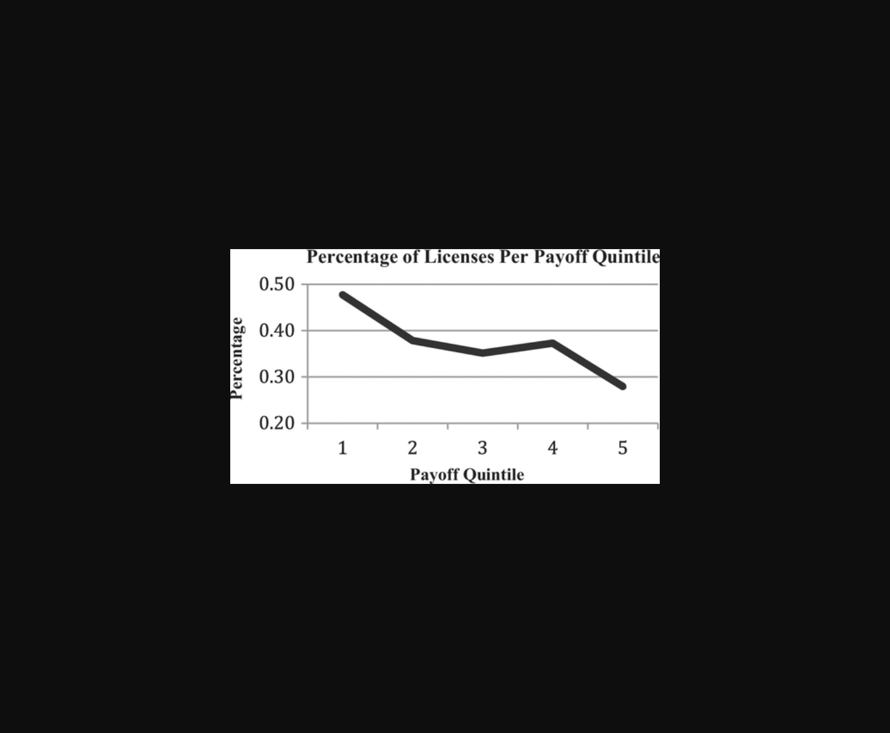
该图展示了明星研究者与团队协作对创新贡献的比例分布及互补性影响。
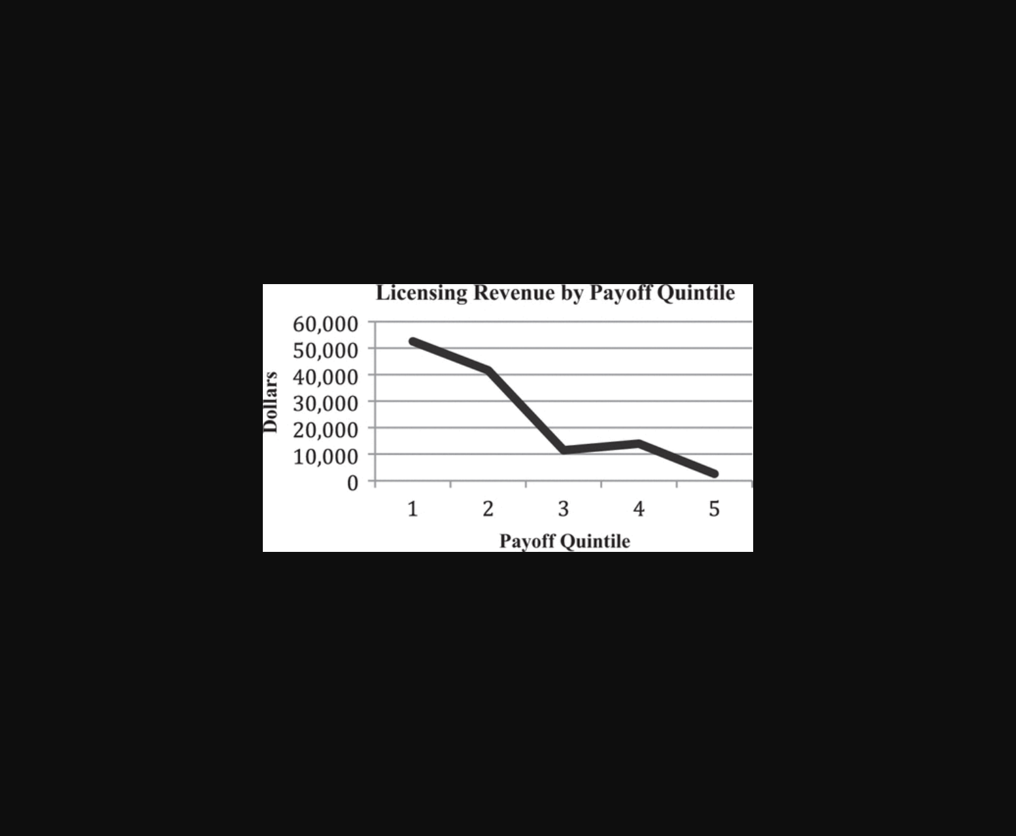
图示合作中明星与团队的互补性及替代性对价值创造的影响。

图示明星与团队在合作中的贡献分布及互补性影响。

图示互补性匹配模型下合作双方对创新产出的贡献比例分布。
原文链接: https://doi.org/10.1287/mnsc.2021.01969

